Content Strategy

Prepared Exclusively for

Ennistymon Equities LLC, d/b/a
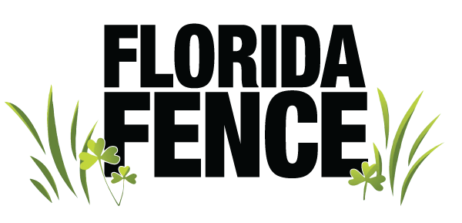
February 17, 2017
Distribution Restricted (see notice on final page)

In order to grow revenues, Florida Fence has engaged Grow the Dream to create a customer-centered content strategy plan to establish credibility, win the trust of prospects, and accelerate its sales process by delivering value through incredible content that can be used to explode their marketing efforts.

At the end of the day, the most strategic objective is not so much to reach as many people in this audience as possible, but instead to reach a small, strategic subset of them in the most relevant, impactful way possible.

With this custom-tailored content marketing plan, turning prospects into customers will become easier and hopefully more enjoyable as you will have zeroed in on the “right” customer for your business, not wasting your valuable marketing time and budget on the wrong client.

This custom-tailored content marketing plan includes several “Bullseye” Client Personas, your identity as a business, as well as a specific content strategy for Florida Fence that should serve you well for the long term, with specific content ideas for the next 90 days.

“Bullseye” Client Personas

While nobody knows your customer better than you, allowing the GTD team to come alongside and help you articulate clearly who they are will aid in creating a smarter and savvier content strategy, and will ensure that all of our efforts on your behalf are aligned as strategically as possible with your business objectives..

For Florida Fence, the 3 “bullseyes” in your target market are:

Joshua and Emily Harris

- Married couple, age 38
- He’s a software developer, and she’s a nurse.
- Middle to upper income level
- Their daughter is in elementary school
- They have 2 dogs
- Live in a gated community with a pool
- They want:
  - To keep their child and pets safe from unsavory characters and predators
  - Privacy
  - A property upgrade that is functional but also aesthetically pleasing
- They have:
  - A list of possible upgrades to their home and property, and the need to prioritize which one(s) they can do this year
  - A need for a fence for these reasons:
    - Pets need a place to run around outside, but could get out if not properly fenced in
    - Insurance requires the fence because of their pool and the need to avoid liability
- Emily does the initial research and inquires, but Joshua is involved in the final decision and likes to find out for himself.
- They aren’t buying on impulse, therefore they’ll take their time and get the decision right before spending the money. It might take them several weeks to sign the contract after they have a first meeting.
- They are BOTH decision makers
- More pics, and the rest of the pics.

Frank and Maria Frenna

- Married couple, age 59
- He’s an executive, she’s a homemaker
- They are devoted pet owners
- They recently bought their home in Sarasota/Manatee, but he still flies back “up North” often for work.
- They’re “empty nesters,” but they are mindful of their 2 adult children, and 3 grandchildren that will come to visit.
- They want:
  - A quality product that will look great and last for years to come
  - Reliability and dependability
  - Their investment/upgrade in their property to present well to others in their community and to their invited guests
- They have:
  - recently sold the home they raised their family in up north
  - considerable disposable income
- They enjoy
  - Dining out,
  - Boating,
  - Culture,
  - Entertaining
  - Golfing (Frank)
  - Gardening (Maria)
- Frank is typically the decision maker, but he wants Maria to be happy with how their home looks.
- They are interested in:
  - Maintaining an active lifestyle into their retirement years
  - Getting the most out of life
  - Involvement in their local church
- Photo
- Frenna = Fresh retirees, empty nesters, and new arrivals, but it’s also an Italian surname

Mark Jones
- Mark is a 52 year-old dentist who owns his practice, which is located in a small office building which he owns. It has some other commercial buildings on either side, but has residences behind it.
- He also owns a half-dozen rental properties.
- Mark’s 20+ years in business has made him a savvy buyer.
- He likes to obtain multiple bids,
- He often (but not always) makes his decision based on price and value, so he’s “budget-minded.”
- Typically more educated buyer than residential buyers
- He does his homework and typically has a relatively high product knowledge and competence regarding fencing products
- Mark likes
  - Things to go smoothly
  - Companies that do what they say they will do
  - Getting a good return on his investment
- More pics
- (Light Commercial Business Owners)

Florida Fence’s Core Identity

Florida Fence exists to provide superior fence products and installation coupled with an unparalleled customer service experience resulting in safety, security, and abundant peace of mind for our customers. In addition to providing excellent products and service, we endeavor to create a legacy for future generations characterized by integrity, endurance, and prosperity. This means that we employ long-term thinking rather than looking for shortcuts, and we work hard to honor our commitments and create a seamless, pleasant experience for our customers.

When working with Florida Fence, clients can expect us to:

- Listen to their needs and wants
- Provide quality products
- Honor our commitments
- Provide outstanding customer service that provides surprises or “wows” with every interaction
- Be reliable and dependable
- Communicate well, proactively updating them on progress and being responsive when they reach out.
- Hold ourselves accountable, and to respond well when customers hold us accountable
- Have fun while working with us — making people smile and laugh is mandatory!

We believe in operating by the “Golden Rule” — treat others like you want to be treated — and we aim to Honor God through our work and our involvement with our customers. We believe in finding ways to give back to our community, through volunteer work, charitable contributions, and involvement in worthy causes, with a particular emphasis on our Military.

We serve homeowners and business owners located from Parrish to Port Charlotte, mostly west of I-75, but with a significant potential for growth in the communities east of I-75.

Note: For the purposes of this plan, we’re setting aside major construction projects requiring bid work.

Content Plan

These attributes contribute to Florida Fence’s core identity and are what truly sets you apart from other fence companies. With this core identity as well as your “bullseye” client personas, the following content constructs were created...

Content Calendar for Florida Fence

Topic Categories to Start With:

- Fence Installation
- Home Improvement
- Local activities
- Pets

Continuous Content Themes

- Superior products
- Outstanding Customer Service
- Accountability to customers
- “We go out of our way for you, our customers!”

Specific Content Ideas

These are blog post ideas based upon your “bullseye” buyer persona, your value propositions, the topic categories and themes identified above, and keyword research.

Post Title: | General Focus: | Publication Date:
How Florida's Rainy Season Affects Your Fence: From Installation and Beyond | This post talks about how Florida’s rainy season affects installation and fences in general, primarily wood. | Published 3/3/2017
Picket’s Pick: Sarasota’s Best Dog Parks | Picket takes us on a tour of his favorite places to sniff butts. | Published 3/10/2017
Big Box Store Wood Fence or Custom Made Wood Fence: Which is The Wiser Choice? | This post will discuss the benefits of stick building vs prefabricated panels. | Published 3/17/2017
Gate Frames: A Custom Job! | This post will focus on our specialty of custom gate frames. | Published 3/24/2017
How to Pay for Your New Fence: Fence Financing Made Easy (Moved this blog post up towards the top since you marked it priority, Theresa!) | This post will focus on the financing available to our customers through Green Sky. (resource needed) | Published 3/31/2017
ON HOLD--Cypress vs Pressure Treated Pine: What’s the Difference for Your Wood Fence? *We will be revisiting this after consulting with the wood expert Dane is going to connect us with. | This post will focus on the differences between cypress and pine and which one is better for our local area, the environment, the longevity of your fence, and your maintenance/upkeep requirements. | *On hold until further information is obtained
Ways to Landscape Along Your New Fence Line | Discuss the best ways to creatively and aesthetically landscape along and around a fence. Reference content from TheSpruce.com Bonus: other ways to beautify (e.g. ornamental posts, birdhouses, etc.) | Published 4/7/2017
Is Your Fence Salt Tested? | Discussing the differences between various types of powder coating for metal fence products, how “Salt” tests work, which types of materials we will and will not sell. (resource: Ideal Aluminum, Gary Stevens) | 4/14/2017 (Pending, waiting for input from Dane)
What Do the Other Dogs Say About Florida Fence? (And Their Owners, Too!) | Written from Picket’s point of view: highlighting our outstanding reviews in Angie’s list and the Better Business Bureau. (Include testimonial/pics from Dachshund Rescue) | Published 4/14/2017
Posts, Rails, and Pickets...Oh My! | This blog post discusses the anatomy of the different types of fences. | Published 4/21/2017
In Florida, Even Your Vinyl Fence Should Use Sunscreen! | This post will focus on the fact that your vinyl/pvc fences should have sunscreen in order to protect them. This is something to look for in a vinyl fence purchase. The Bufftech line of fencing will be mentioned as the high end line which features UV inhibitors, WindZone performance, and the ability to purchase it in DIFFERENT COLORS. | Published 5/5/2017
Exterior Design Trends 2017 | Solar energy, low maintenance materials (including vinyl fences), Florida’s native plants, aging in place (both interior & exterior facets), outdoor color trends. (Link to previous post to include info re: color of vinyl fences) | Published 5/15/2017
Fence Appeal: Why a Fence Might Help Your House Sell Faster! | You’ve heard of curb appeal… here are the benefits of having a fence when selling a home. (Visual appeal, big bonus for pet owners, code compliance if you have a pool, etc.) *include the concept of including more than one style of fence in order to be budget friendly! | Published 5/18/2017
Picket’s Pick: Supporting Our Local Military-Owned Businesses (write the week before Memorial Day Weekend) | This post will focus on Picket’s favorite local businesses that are owned or run by military/former military personnel. Businesses to include will be Phillipi Creek Oyster Bar, JDubs Brewing Company, and others you would like to highlight | Published 5/25/2017
Why You Need a Survey Before We Install Your Fence | *Blog Topic added after creation of this topic | Published 6/12/2017
Why It’s Important Your Wood Fence Doesn’t Touch the Ground | *Blog topic added after creation of this document | Pending Publication-Theresa requested to think about this one longer
Ten Tips on How to Be a Good Neighbor | This post will share 10 ways to be an excellent neighbor, and of course, one of the ways is by having a fence!  Reference material from CollegeCentral.com | Published 7/5/2017
Are You Working for a Living or a Legacy? | Discussion of long term thinking vs. making short term profits, and why we make the kinds of decisions we make. *include Shoes for Orphan Souls as part of this blog post to reflect long term thinking, missions focus, as well as putting up fence with donated time/materials AND babysitting for foster family with 6 kids in 2016, Boy’s and Girl’s Club Fence, fence work around Bayside-- special Florida Fence sign made that has church scripture on it Eph 3-20-21.... | Pending Publication
How Do I Know A Fence Company Is Reliable? | This post will focus on helping a customer understand what makes a fencing company reliable--experience (# of years verifiably in business), dependability, and and how to spot red flags. | Waiting Approval From Theresa
Employee Spotlight: Meet Dane Champlin | Why we hired Dane, his background, his experience, and other fun facts. (Do quarterly)
Picket’s Pick for Puppy Pickets | This post will focus on the “puppy pickets!”A puppy picket fence is a special type of aluminum fencing for dogs that has a narrow row of pickets at the bottom of the fence. Additionally, discuss why “traditional” fencing is a better choice than electric or invisible dog fences as these fences can scare or frighten them.
Navigating Your HOA | How to work with your Homeowners’ Association to make sure your fence design gets approved and your installation process goes smoothly.
Ways to Work with Your Neighbor When Installing Your Fence | This post will focus on putting your best foot forward and working well with your neighbor, why the good side needs to face “out” (county ordinance for Manatee Co.), make sure you know your boundaries, is it YOUR fence if you’re replacing a fence, consider two-sided fence so you both can have the pretty side, etc.
Picket’s Pick: Best Dog Resort in Town-ON HOLD--I see you sent me two emails with pictures of Bayside Pet Resort, Theresa. Does this mean you are comfortable with proceeding with this post? :) | All about why Picket loves Bayside Pet Resort! (Should there be some honorable “barks” / mentions of some other pet places that might refer us business?) Include pictures of Bayside Pet Resort
Fence Trends: Report from Industry Leaders & Style Innovations | (Assuming there’s a trade show where manufacturers show off dreamy future stuff) We highlight some of the major changes in fence design in recent years and showcase some of the fancy new stuff to come. (Need to further research, Fencetech 2017, etc)
Making Fence Dreams Come True | Photos & stories of some of the most unique ideas that Kevin Dermody has brought to life!
Picket’s Pick: Fire Pits for Florida Backyards | Some winning concepts from Pinterest on ways to make your backyard sizzle for the summer. Bonus: how to stop the mosquitoes from biting during your BBQ.
Keeping it Private: Best Fence Designs for Privacy | People buy fences for lots of reasons: keeping pets safe, keeping predators out, even improving the curb appeal (link to “fence appeal” post) of their home. But here’s how to keep the prying eyes of your nosy neighbors out of your business! Best fence types for privacy include tongue & groove PVC/vinyl, board on board wood (still might shrink and swell), don’t want stockade, etc)
*Below are blog post topics you requested after the creation of the Content Calendar
Legal Requirements for a Pool Fence: What You Need to Know to Protect Yourself | Refer back to email/  We have found that the folks who work out of their trucks are often not knowledgeable on building codes
Sunshine 811 Locate Flag Colors: What Do They Mean? | Comments from email: Sometimes we receive a call that the locate was not done when in fact it was, only there was nothing to locate so there are no visual signs left.  Would like to address that in the blog post and emails.  There is a color chart of what the different color flags mean which should be helpful to the client to understand what is living below them.
Why You Need a Survey Before We Install Your Fence |  | Published 6/12/2017
Why Your Wood Fence Shouldn’t Touch the Ground |  | Written, not published
Bid Department Blog Post | Show off bid work | Waiting to receive more pictures in order to start blog post

In Conclusion

Based upon our interactions with your team, the Grow the Dream team is confident that, with this plan, Florida Fence is poised to create content that will establish your online presence in such a way that you are recognized as the leader in the fence and gate business in the area.

We’re looking forward to seeing significant success in your efforts in 2017!

Best,

David G. Johnson
Growth Engineer
dj@growthedream.com
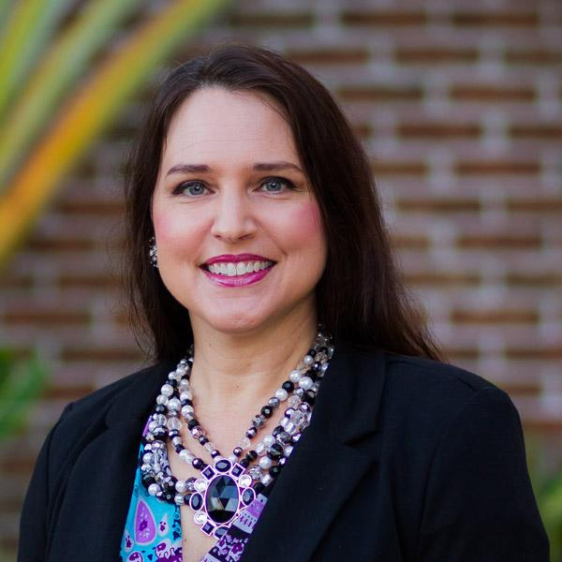

Jill C. Johnson
Writer, Creator, Manager
jill@growthedream.com

Confidentiality Notice: This report and its contents are the proprietary data of Epiphany Marketing, LLC d/b/a Grow The Dream and are prepared exclusively for the internal use of My Signature Living. Distribution beyond staff and appropriate contractors/vendors is prohibited without express written consent.

Copyright © 2017 Epiphany Marketing, LLC d/b/a Grow The Dream

